**2025 State CIF/CGA**

**Girls Golf Championship**

**Wednesday, November 19, 2025**

**Poppy Hills Golf Course**

**Pebble Beach, CA**

**CIF STATE GIRLS GOLF CHAMPIONSHIPS**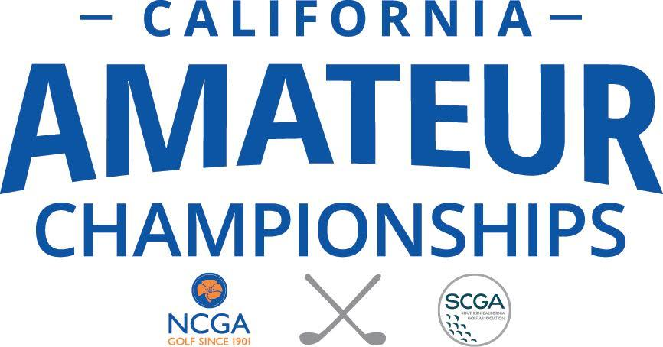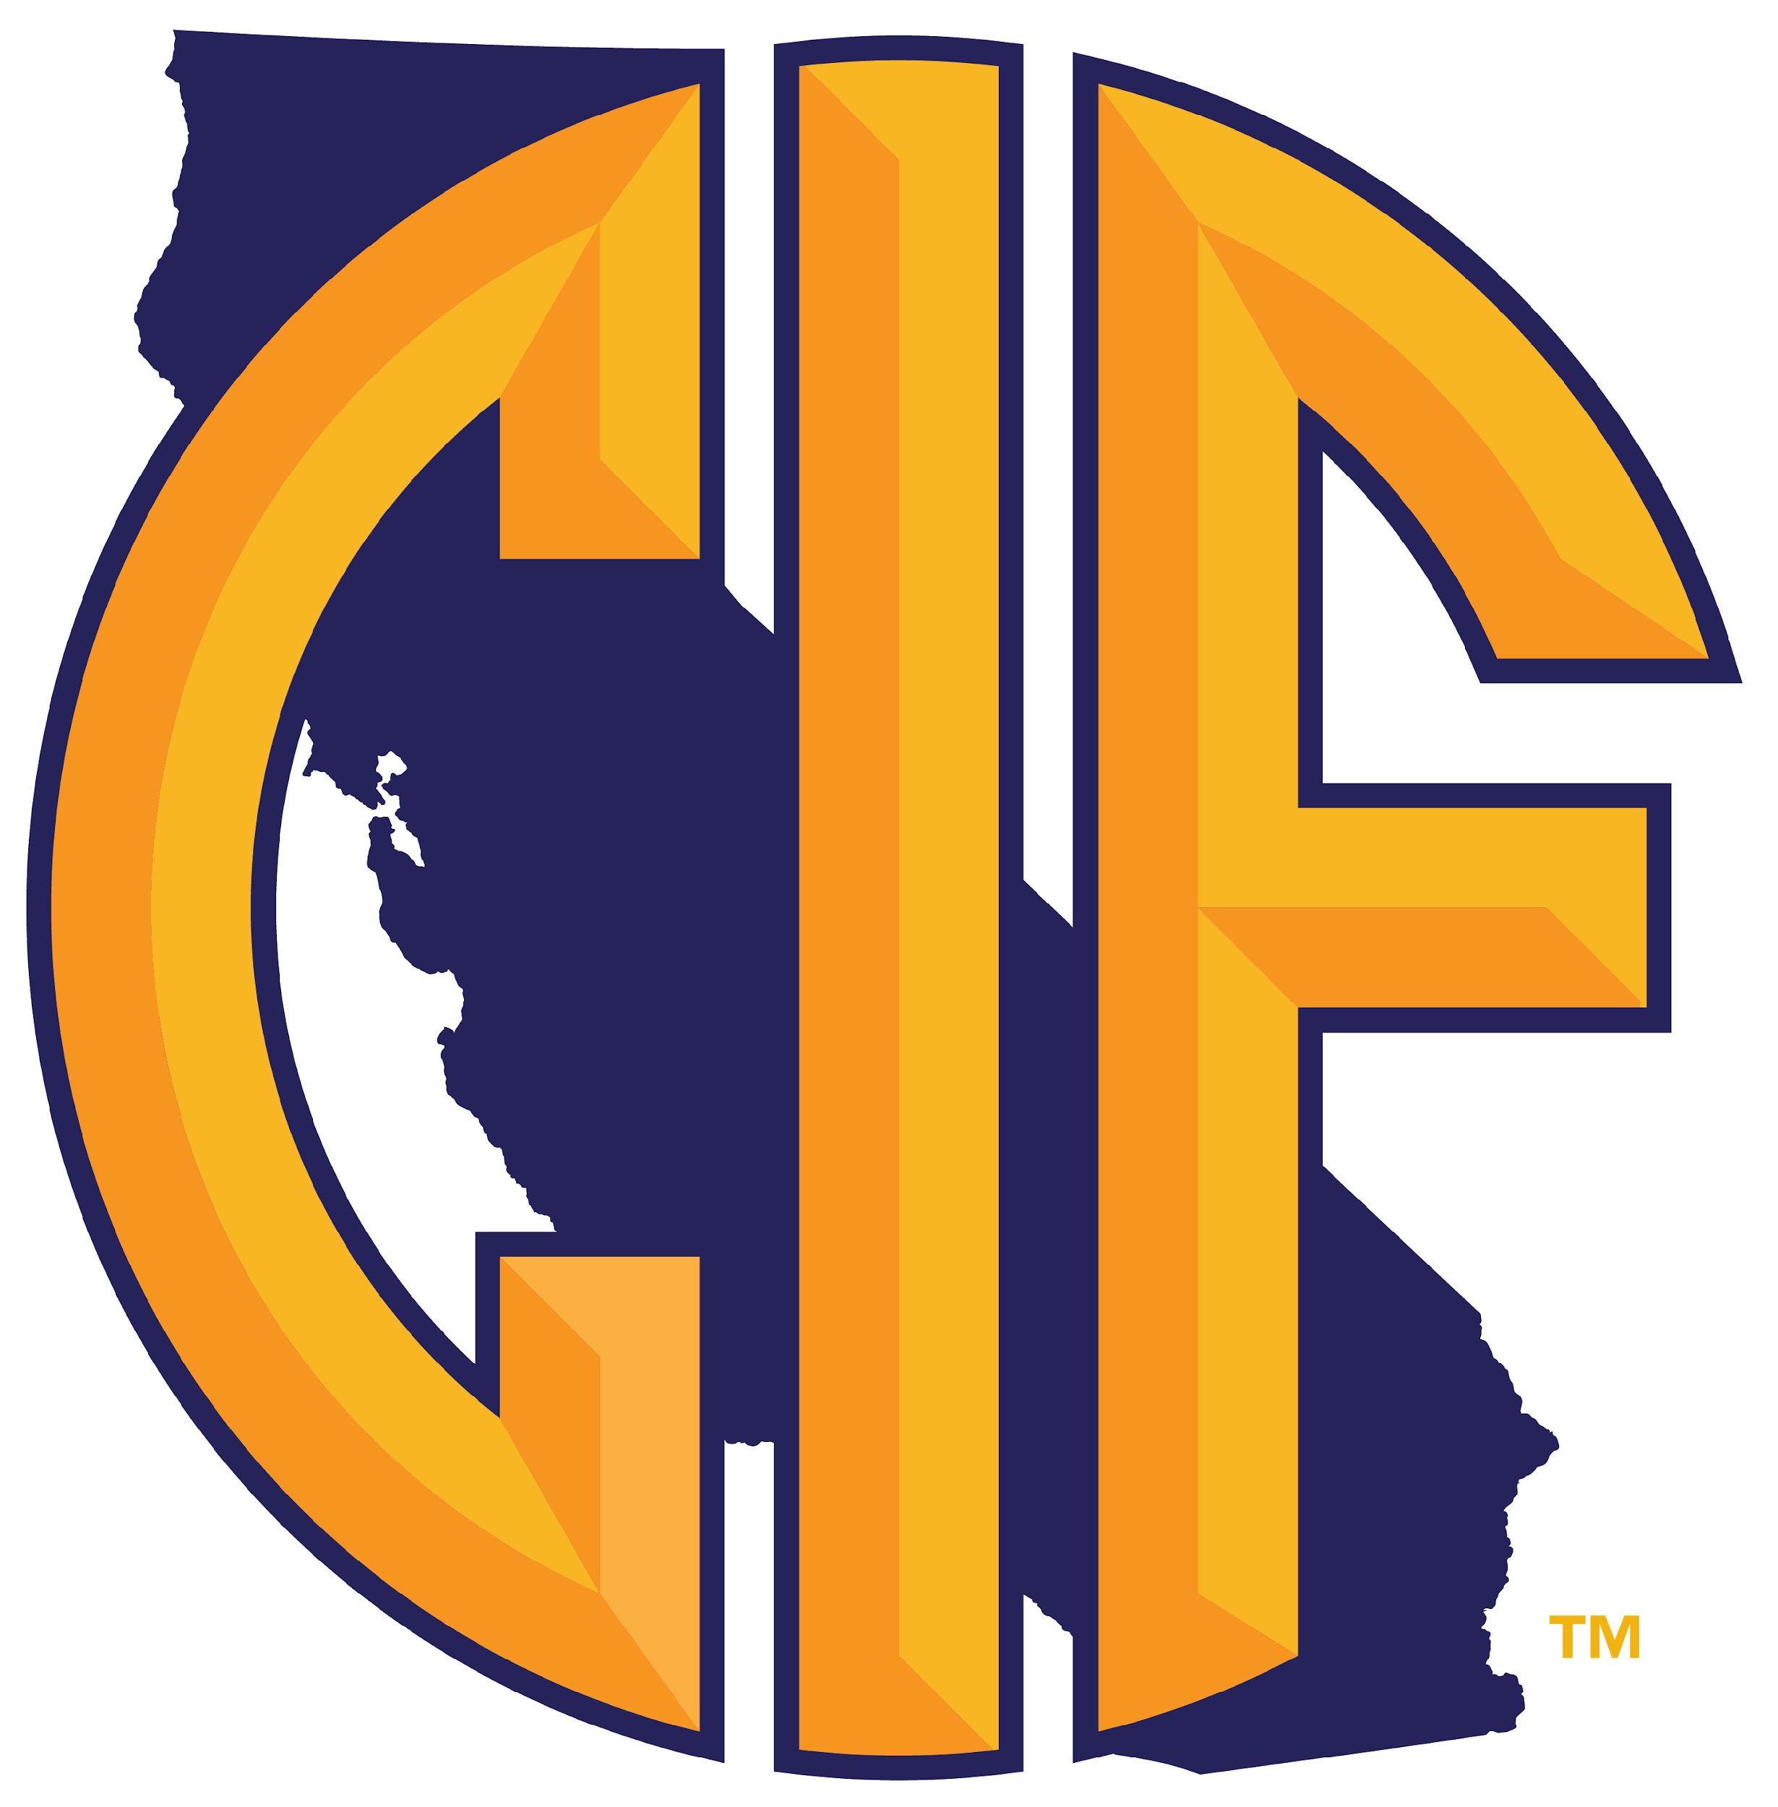

⬥ ⬥ ⬥ ⬥ ⬥ ⬥ ⬥ ***NOTICE TO CONTESTANTS*** ⬥ ⬥ ⬥ ⬥ ⬥ ⬥ ⬥

Congratulations on qualifying to participate in our Girls Team and Individual CIF/CGA State Girls High School Golf Championship. We look forward to meeting you and hope that you will have an enjoyable day.

We are most grateful to Poppy Hills Golf Course for making its fine course available for this event and, as guests, please be reminded that we are all obligated to follow the standards which have been established for guests of the club.

The CIF would like to thank the California Golf Association (CGA) for their generosity and support of these championships.

Thank you in advance for your cooperation and, once again, welcome to the tournament. Everyone is anticipating outstanding competition among California’s finest high school players.

NCGA/CIF Co-Chairpersons:

Haley Whitbeck, NCGA Committee Chairman

Brian Seymour, CIF Committee Chairman

⬥ ⬥ ⬥ ⬥ ⬥ ⬥ ⬥ ⬥ ⬥ ⬥

# **OFFICIAL TITLE**

The official title of this event is the **2025 State CIF/CGA Girls Golf Championship**

**MANAGEMENT**

The CIF State Girls Golf Championships shall be under the jurisdiction of the State CIF, Brian Seymour, Associate Executive Director. The championship event will be managed by the Northern California Golf Association and Haley Whitbeck, NCGA Director of Junior Golf. **Questions can be** **addressed to the NCGA at (831) 625-4653.**

## **CIF CHAMPIONSHIP EVENT COORDINATOR**

### **Brian Seymour**

**Cell Phone: (916) 899-4218**

E-mail: [**bseymour@cifstate.org**](mailto:bseymour@cifstate.org)

*In the case of unforeseen circumstances, the CIF State Office reserves the right to change Championship dates, times, and locations in the best interest of all involved.*

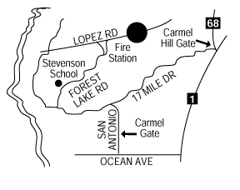

# **DATE AND SITE**

Wednesday, November 19, 2025

Poppy Hills Golf Course

3200 Lopez Road

Pebble Beach, CA 93953

# **DIRECTIONS TO CLUB**

From Highway 1 from the South or Highway 68 from the North take the Carmel Hill Gate to Forest Lake Road. Turn right to Lopez Road. Turn right on Lopez Road to Poppy Hills Golf Course.

# **CHAMPIONSHIP FIELD OF 54 PLAYERS**

NorCal/SoCal Regionals: Three six-person teams plus the top nine individuals not on qualifying teams (total of 27 players from each Regional Championship).

# **REGIONAL TOURNAMENT DIRECTOR/ENTRIES**

Regional Tournament Directors are to email final results to **Haley Whitbeck at the NCGA** [**hwhitbeck@ncga.org**](mailto:hwhitbeck@ncga.org)immediately following the finalization of regional tournament results.

# **COACHES MEETING**

There will be a coaches meeting at the NCGA Offices beginning at 5:00 pm on Tuesday, November 18. It is highly recommended that the coaches be in attendance. The meeting will take place in the Jones Room in the NCGA offices. The NCGA will review the local rules, the conditions of the competition and distribute pairing sheets.

# **TOURNAMENT REGISTRATION**

All coaches/school officials that are unable to attend the coaches meeting on Monday must check-in and register at the registration table in the clubhouse entrance, prior to the assigned pairing times of your team or individual(s) player.The high school coach or authorized staff member must accompany players, and will be the only person allowed to sign in. The NCGA official starters will hand out all the necessary materials (local rules, scorecards etc.) to the players at the tee when it is the player’s turn to play.

Bylaw 503.E.:

**No CIF team (or individual) shall participate in interscholastic or approved competition with any other team unless the CIF team is under supervision as required by the California Education Code 49032.**

Bylaw 503.F.:

**All coaches of CIF member school teams must meet the requirements of the California Education Code 49032, 35179.1 and Bylaw 22.B.9.**

Further, it is important to note all coaches must remain on site throughout the competition.

# **SUBSTITUTIONS**

Each Regional/CIF Site Director will be responsible for designating substitutes in the event of any cancellations. A vacancy will be filled only by the next qualified individual player or team. **Substitutions on the day of the tournament will not be permitted**. Changes can be made with Haley Whitbeck prior to November 17, 2025.

# **STARTING TIMES/PAIRINGS**

Eighteen groups of three will play from the 1st tee beginning at 8:00 am.

**NOTE: It is the player’s responsibility to be at the assigned tee on time. Players will**

**not be paged. All players MUST be at the assigned teeing area ready to play when the**

**first player in their group is announced for starting. Late players are penalized two**

**strokes if they are not at their assigned teeing area ready to play at their assigned tee**

**time. After five minutes, players are disqualified. See Rule 5.3a.**

Pairings will be available at the NCGA web page ([www.ncga.org](http://www.ncga.org)) and the CIF website ([www.cifstate.org](http://www.cifstate.org)) after November 13. Pairings will alsobe distributed at the coaches meeting on Tuesday afternoon and posted in the pro shop.

# **CLUBHOUSE AND PRO SHOP**

The clubhouse and pro shop will be open at 6:00 am for contestants and coaches during the tournament. Contestants are requested to arrive dressed “ready to play.” Restrooms will be available at the Clubhouse.

# **DRIVING RANGE**

On Wednesday, November 19, the driving range will open at 7:00 am. Practice balls will be at the range and will be hosted by the CGA. Players are required to pay for range balls on Tuesday, November 18, unless they play in the scheduled practice round organized by CIF.

# **FOOD**

**Breakfast**-Breakfast will be available, starting at 7:00 am. Please allow for extra time due to the possibility of a large group requesting breakfast.

**Lunch**-The NCGA will host a lunch for all players, one coach per team/individual, and Tournament Officials immediately following play. Awards will be presented at that time. Coolers may not be brought on the property by players, coaches, or gallery.

**Snack Bar**-The walk-up window will be open at 9:30 am.

# **DRESS REQUIREMENTS FOR PLAYERS/COACHES/SPECTATORS**

**Men:** Golf shirts are required. Hemmed shorts may be worn and must be no shorter than mid-thigh (no jean shorts). Blue jeans (including any color designer jeans), T-shirts, tank tops and cargo shorts are prohibited.

**Women:** Golf shirts, slacks, skirts, or hemmed shorts with no shorter than mid-thigh (no jean shorts) are permitted. Blue jeans (including any color designer jeans), T-shirts, tank tops and cargo shorts are prohibited.

**IMPORTANT**: Shirts must be tucked in (if designed to be worn in) and hat bills are to be worn forward. All spectators are expected to adhere to the dress code.

# **FOOTWEAR**

The Local Rule as prescribed in Section 8 of the Committee Procedures is in effect.

Model Local Rule G-7. Penalty for breach of Local Rule – see Rule 4.3.

**PRACTICE ROUNDS**

Practice rounds can be reserved by calling the Poppy Hills Pro Shop at (831) 625-1513. Practice rounds are $75.00 per player. A straight start is available for individuals or teams starting at 10:30 AM on Tuesday, November 18th. This block of time is reserved for players only, no coaches. These times will be released to the public on Saturday, November 15. You **must call** by November 14 to reserveyour time, where a credit card will be put on hold to secure your players spot. If a card is on file for the players and the player no shows the practice round the card will still be charged. Players are to walk during practice rounds (no carts). Coaches may rent a cart to follow their players.

**RULES**

The 2025 USGA Rules of Golf apply. The starter will distribute local rules of play that apply during the tournament to all contestants when it is their turn to play.

**Advice: Participants are reminded of Rule 10.2a (Advice) of “The Rules of Golf” which specifically prohibits players from receiving any counsel or suggestion from anyone (including their coach, other players, gallery, etc.) that could influence them in determining their play, the choice of a club, or the method of making a stroke. *Note: Information on the Rules of Golf and Local* *Rules for this tournament are not considered to be advice.***

**Distance Measuring Devices:** Players may obtain distance information by use of a

distance-measuring device. If, during a stipulated round, a player uses a distance-

measuring device to gauge or measure other conditions that might affect his play (e.g.

elevation changes), the player is in breach of Rule 4.3a(1). The device used may not be

a cell phone. Any questions about such devices should be resolved before the start of

the stipulated round.

# **Tees**: All play will be from the NCGA Tees and the course will set for approximately 5900 yards.

**TOURNAMENT FORMAT (18 holes of stroke play)**

**Individual Competition:** All girls who have qualified for the individual competition or team in their respective CIF regional events shall be eligible to compete in this category. In individual competition participants will play 18 holes of stroke play. In the event of a tie for 1st place there will be a sudden death playoff commencing from the 1st tee. Ties for 2nd place thru 5th place will be decided by USGA Score Card Matching procedures. Ties for 6th place will receive duplicate awards.

**Team Competition:** In addition to the individual competition, there will also be team competition. The teams representing each regional will consist of six players, and the best five of the six players scores will count in determining the team champion and runner-up.

In the event of a tie for 1st or 2nd place in team play, the tie will be decided by adding the sixth players’ score to the team total. If the teams are still tied, the tie will be decided by using the USGA recommended tie breaking procedure which totals the scores of all six players on each team for holes 10-18, if still tied holes 13-18, if still tied holes 16-18, if still tied hole 18.

# **AWARDS**

Team awards will be presented to the champion and runner-up teams following the completion of the event. Awards will be presented to the first six place winners in the individual competition.

# **ELECTRIC GOLF CARTS, CADDIES, AND PULL CARTS**

Players must carry their own clubs. **Manual push/pull carts will be permitted**. Players must bring their own push/pull cart. Caddies and electric carts and/or electric push/pull carts are not permitted. **SPECIAL NOTE: Coaches are permitted to rent a cart for the championship. Spectators are not allowed to use golf carts during the championship.**

# **GALLERY**

##### **Spectators are permitted; however, all spectators must remain at a distance of 30 yards from players at all times and are not to walk on the fairways. No cell phones, camera phones, walkie-talkies, pagers or other communication devices will be allowed on the golf course.**

**MISCELLANEOUS**

This tournament is open to eligible high school players only. No coaches will be permitted to play in this event, including the Monday practice rounds. It will be the responsibility of the NCGA Tournament Committee to staff and conduct this tournament. Haley Whitbeck of the NCGA and Brian Seymour, of the CIF are Tournament Co-Chairpersons.

**\*\* Pairings will be available at the NCGA web page (**[**www.ncga.org**](http://www.ncga.org)**) and the CIF web page (**[**www.cifstate.org**](http://www.cifstate.org)**) after November 13.\*\***

**CIF Mission**

## **It’s bigger than sports. The CIF provides students with the opportunity to belong, connect, and compete in education-based experiences.**

### **Every student in California has the unique opportunity to participate and experience being a part of a school team or student organization. The CIF and our school communities support our students’ journeys by developing impactful relationships through transformational educators and coaches who provide a healthy environment for growth and development. It is essential to have families and community supporters who display positive behavior which will allow our students to create their own experiences.**

[**CIF CORPORATE SPONSORS**](https://cifstate.org/sports/Corporate_Sponsors.pdf)